Students:
Name: Daniel Lin
ID: 322594508
Name: Hadar Ferber
ID: 209148535

The features we choose:
Collage of moments feature:
The collage of moments feature is a display of 4 images changing every 2 seconds. When the form loads it fetches all available photos from all albums and creates a list of photos. A timer rotates through the list updating the pictures. The user can return to home screen at any time using “Home” button.
Code of this feature can be found in:
FormCollageOfPhotos.Designer.cs
FormCollageOfPhotos.cs
Statistics feature:
The Statistics feature is a summary of information about the logged in user. When the form loads it fetches information about the user’s posts, albums, photos and liked pages. And calculates total friends, total posts, total photos, total albums, total liked pages, average photos per album and the most likes on a picture. The user can return to home screen at any time using “Home” button or continue to Profile or Photos page.
Code of this feature can be found in:
FormUserStatistics.Designer.cs
FormUserStatistics.cs

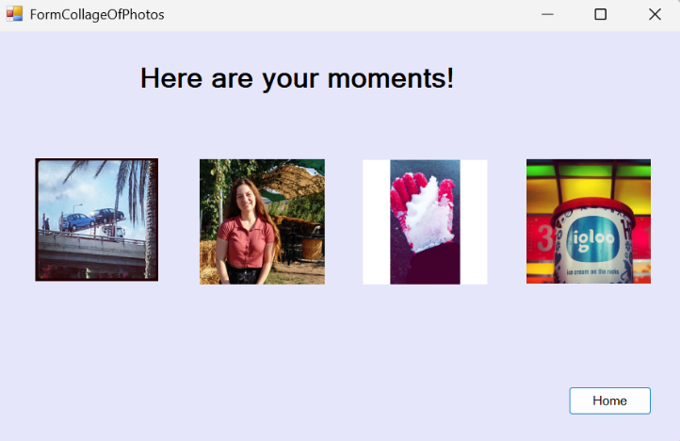
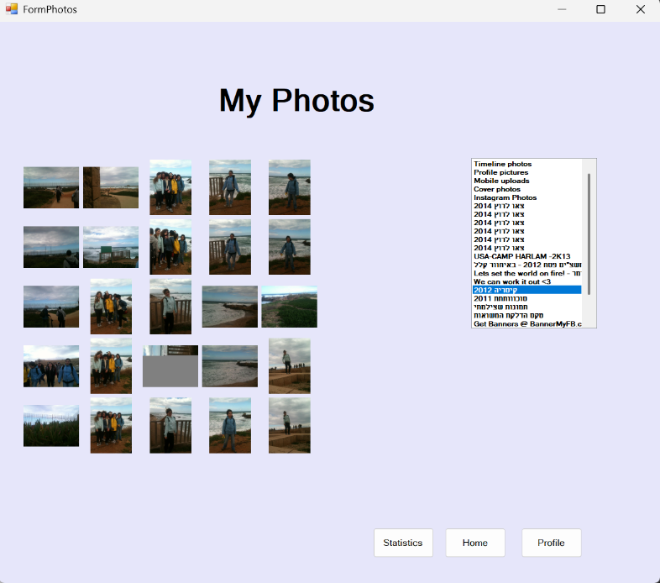
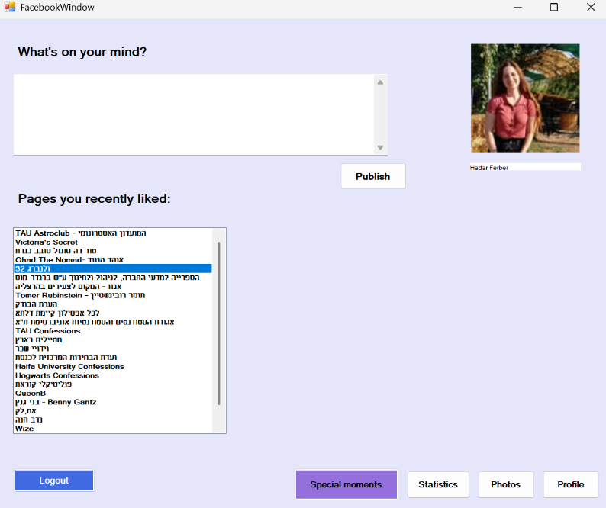
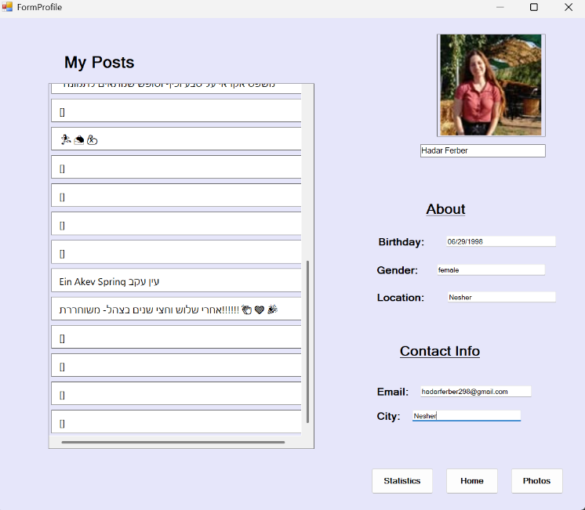
Application screenshots:
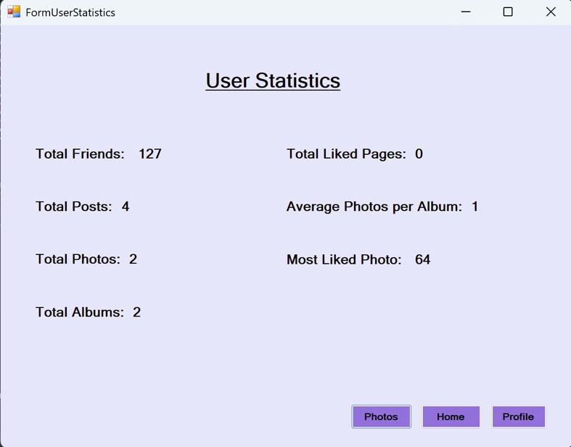

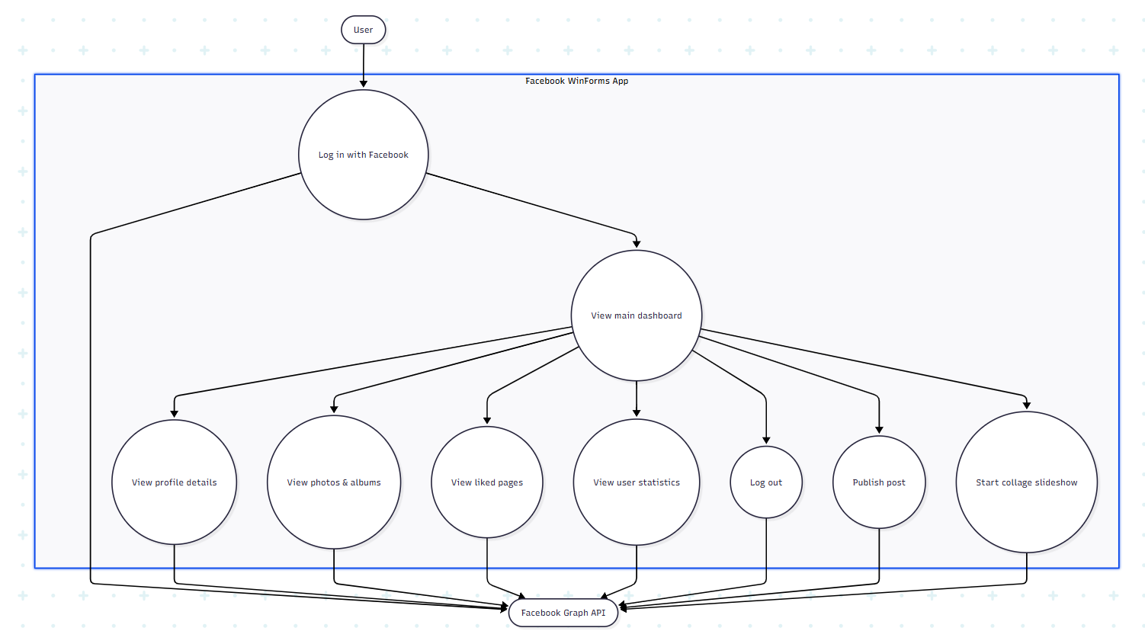
Use Case Diagram:

Collage of moments- Sequence diagram:
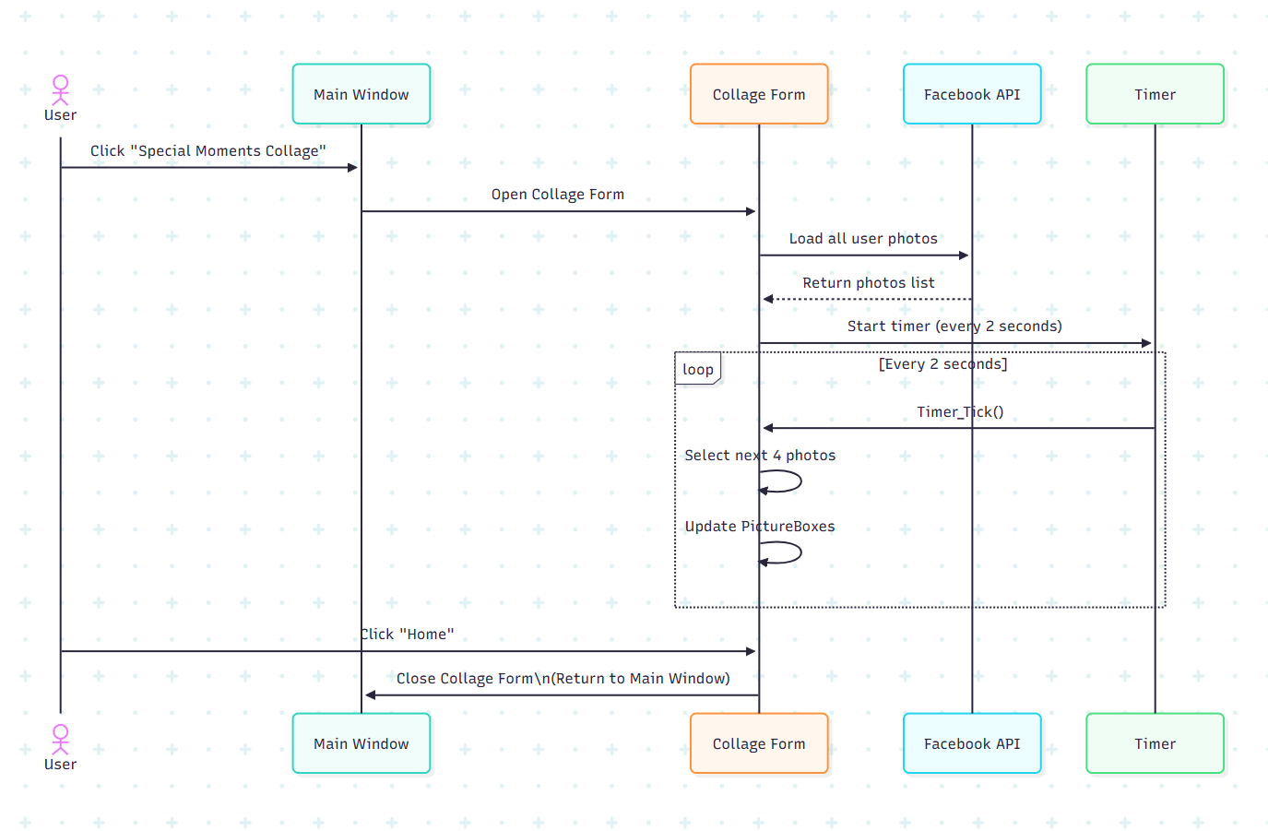

Statistics- Sequence diagram:

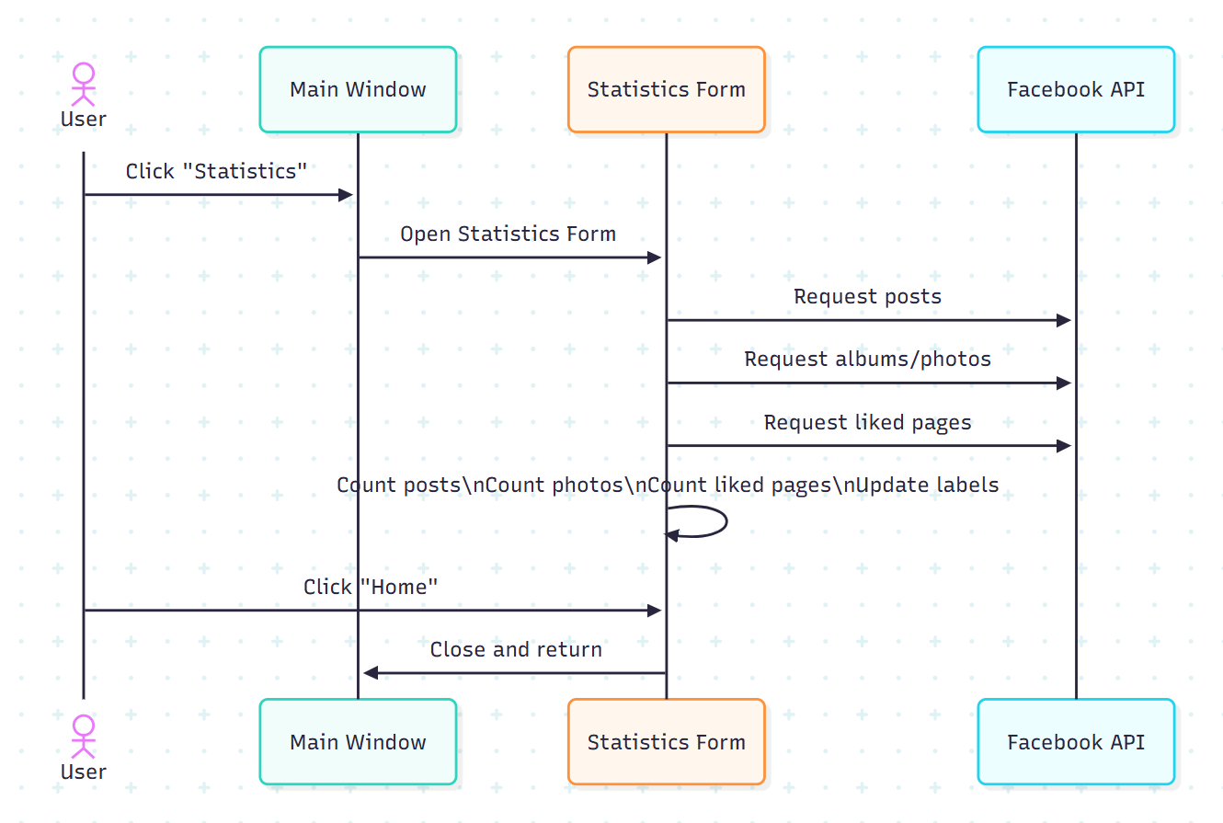

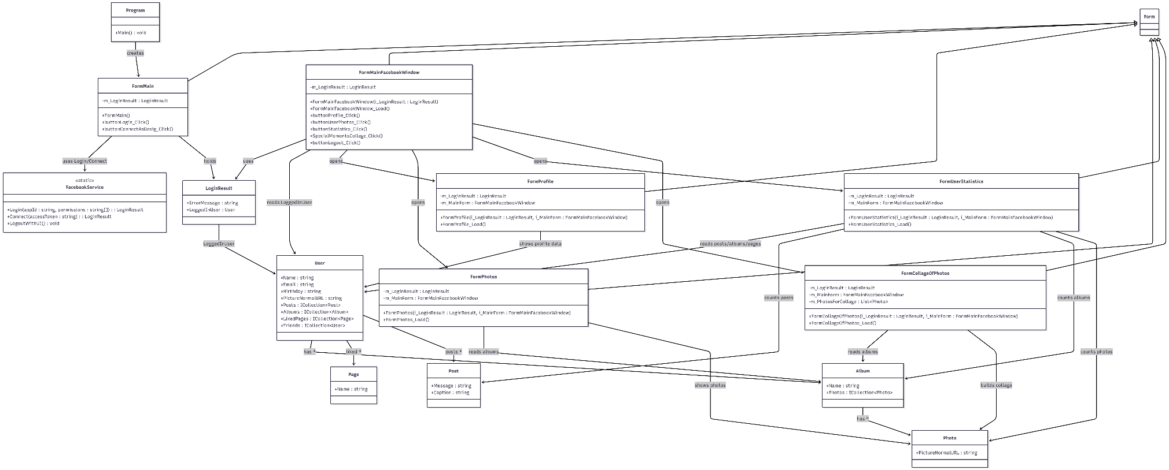
Class diagram:

